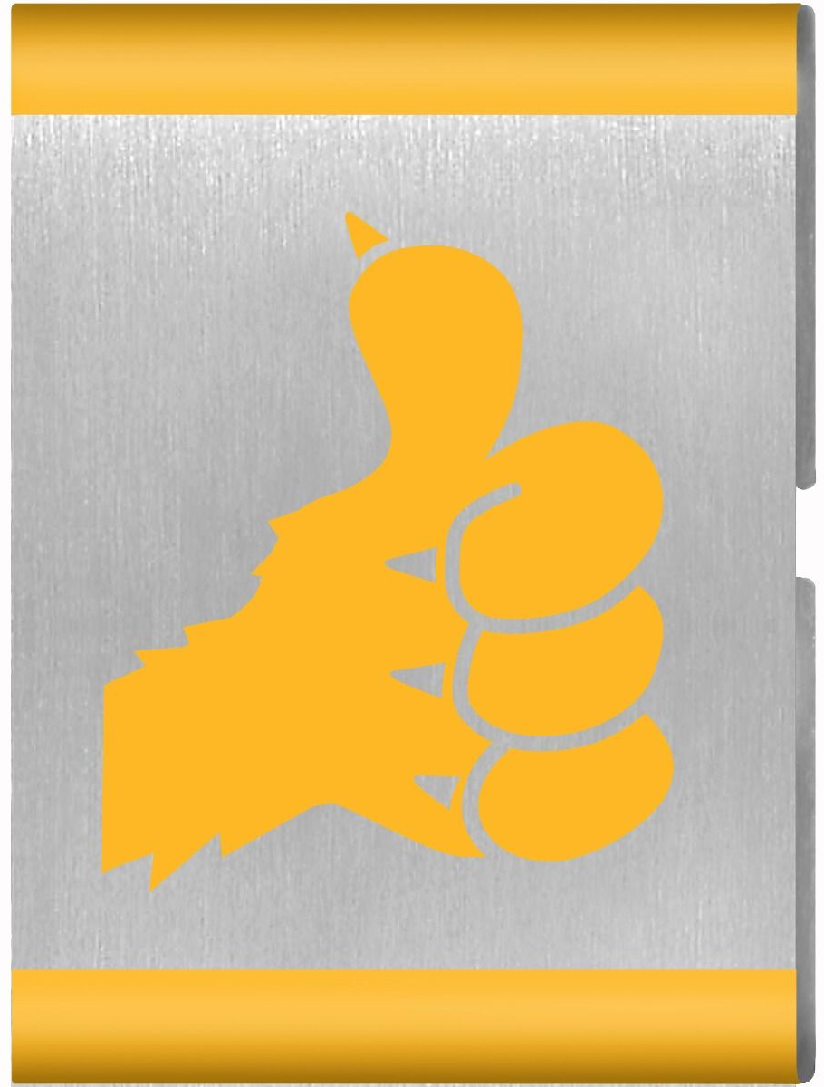
I’ll Do It Myself
Materials

Parent and Leader Guidebook: pages 63-66
Lion Adventure Book: page 13

- Make and use a “Lion bag” and hanger for personal Scouting gear.
- Make a personal care checklist.
- Practice tying shoelaces.

Materials
- Copies of King of the Jungle handout, one per adult
- Copy of Den Meeting Plan, one for leader(s)
- Name tags and Sharpie
- Cub Scouts Poster Set with Scout Law, Scout Oath and Den Code of Conduct
(#621086 from Scout Shop)
- Blue tape or something to hang posters on wall

Optional
- Snack and water
- Activities for siblings (e.g., coloring books)

Gathering: Stackathon
- Simple household materials (e.g., blocks, cups, cardboard boxes, dominoes, cards)

Activity 1: Lion Bags
- Reusable grocery-type bag (one per Lion)
- Decorations (e.g., fabric, markers, stickers)
- Scissors

Activity 2: Personal Care Checklist
- Few extra copies of Lion Adventure Book page 13 (for those who forget book).

Activity 3: Tying Shoelaces
- One shoe with laces per Lion.
Note: many kids do not learn to tie their shoes until late 1st grade or early 2nd grade.

Activity Wrap Up
- Colored pencils, crayons or markers
- Few extra copies of Lion Adventure Book page 7 (for those who forget book).
Den Meeting Plan
I’ll Do It Myself

Parent and Leader Guidebook: pages 63-66
Lion Adventure Book: page 13

- Make and use a “Lion bag” and hanger for personal Scouting gear.
- Make a personal care checklist.
- Practice tying shoelaces.

Gathering
- Stackathon

Opening
- Good conduct candle
- Scout Oath
- Sing “I Like Bananas, Coconuts, and Grapes”

Talk Time
- Den business
- Sharing time
- Talk about things Lions can do for themselves without being told (e.g., brushing teeth, putting toys away, feeding pet, putting clothes away, taking out trash).

Activities
- Activity 1: Lion Bags
- Activity 2: Personal Care Checklist
- Activity 3: Tying Shoelaces
- Activity Wrap-up: Lion Adventure Book, page 13

Closing
- Scout Law
- Grand Roar: “Do Your Best!”

I’ll Do It Myself Adventure

Bananas, Coconuts and Grapes
Tune: Battle Hymn of the Republic

I like bananas, coconuts, and grapes,
I like bananas, coconuts, and grapes,
I like bananas, coconuts, and grapes,
That’s why they call me “Tarzan of the Apes.”
First 3 lines get progressively softer, and the last line gets progressively louder each time it is sung.
Scout Law
A Scout is trustworthy, loyal, helpful, friendly, courteous, kind, obedient, cheerful, thrifty, brave, clean, reverent.
Scout Oath
On my honor, I will do my best to do my duty to God and my country and to obey the Scout Law; to help other people at all times; to keep myself physically strong, mentally awake, and morally straight.
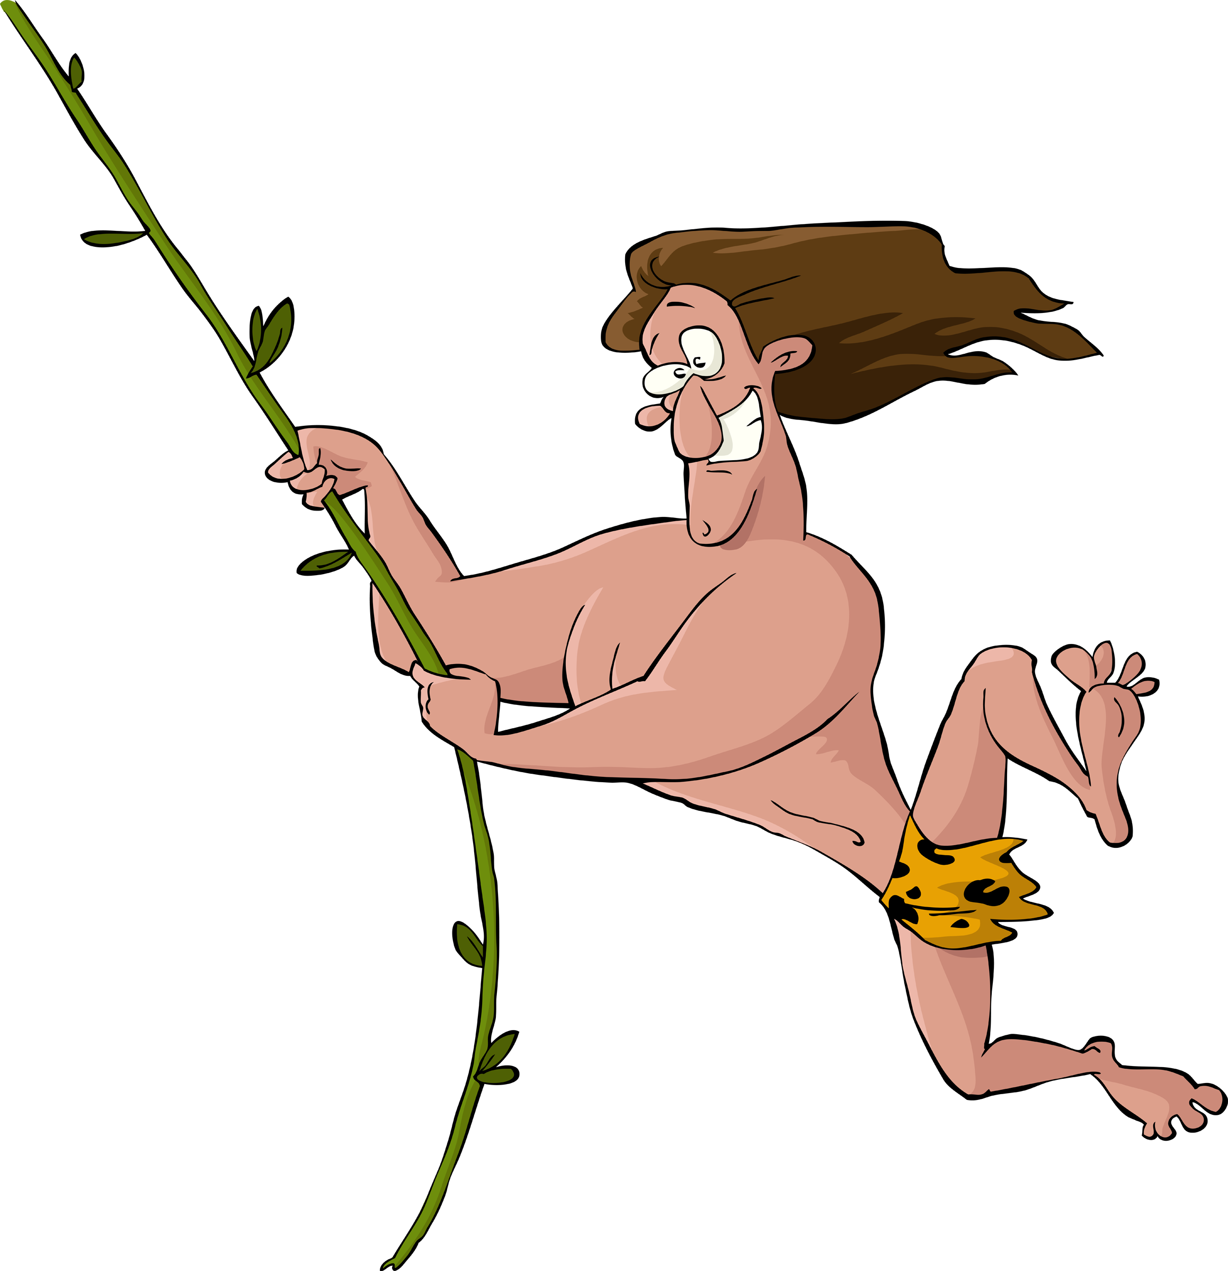

Pack 72
facebook.com/pack72tomball
pack72tomball.scoutlander.com
Orion District
www.orion.shac.org
facebook.com/orionbsa
Sam Houston Area Council
www.shac.org
facebook.com/shac.bsa
Upcoming Events

Dec 16 Wreaths Across America, optional
10:00 am at Houston Cemetery

Dec 20 Pack Meeting
(bring donation of first aid supplies)

Jan 10 Den Meeting
TBD Outing

Feb 7 Den Meeting
Feb 24 Pinewood Derby
Feb 28 Pack Meeting
Mar 7 Den Meeting

Shoe Tying Ideas

Best tips for Tying Shoe Laces! www.yourkidsot.com/blog/best-tips-for-tying-shoe-laces

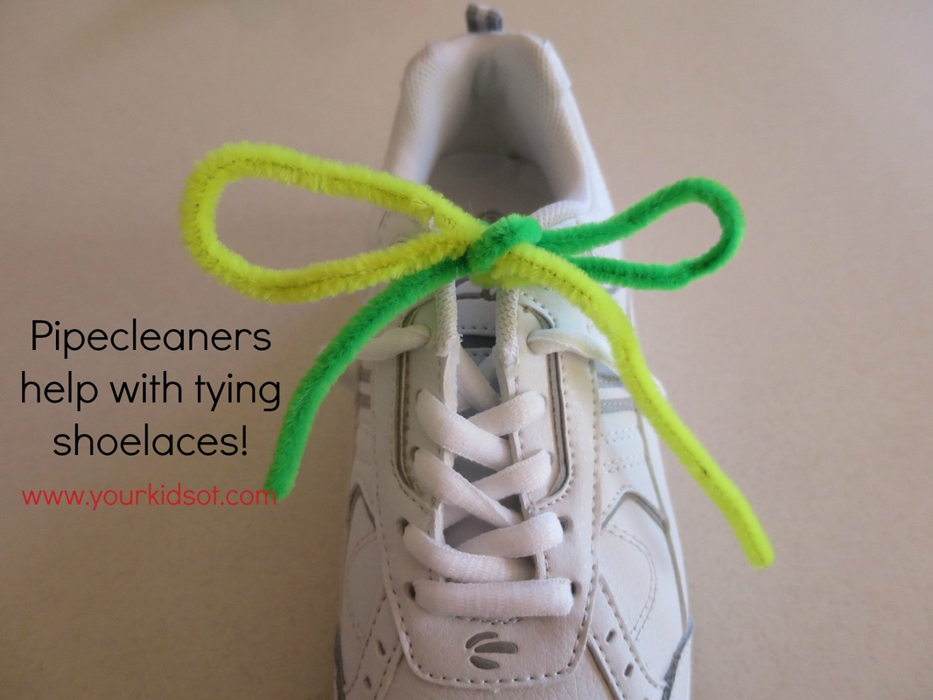
Try attaching two pipe cleaners (different colors) to your shoes to teach shoelace tying. I first saw this idea on Pinterest and it really helps! The stiffness of the pipe cleaners means that if a "loop" is dropped then it doesn't automatically lose its shape. Having two different colors helps to separate out what the left side is doing compared with the right side, breaking down the task into smaller steps. For example, You can say ... make a loop with the yellow pipe cleaner and pinch the bottom of the loop. Take the green pipe cleaner and wrap it around the yellow loop. etc.
Remember to look out for other opportunities to practice tying a bow with your kids! Wrapping presents, ribbon in hair, ties on tracksuit pants, tying a ribbon on a doll or teddy, tying a lead to toy dog, etc. Make the most of everyday opportunities.

Shoe Tying Techniques

There are generally two techniques used to tie shoe laces. The single loop and the double loop methods. Therapy Fun Zone describes these two methods with excellent step by step pictures to guide your child. She even introduces a third method! https://therapyfunzone.net/blog/shoe-tying-methods/

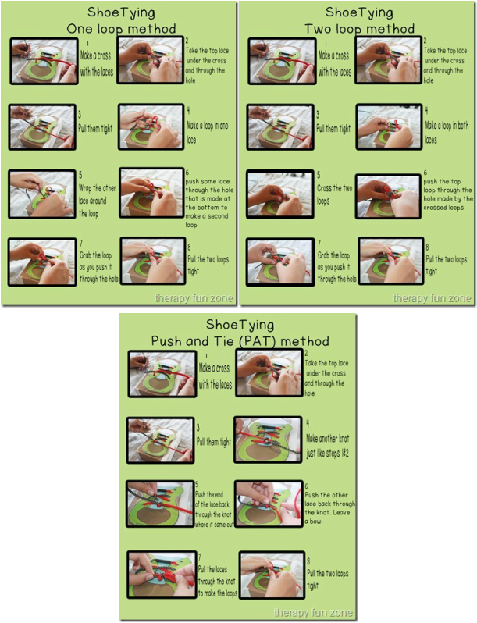

Lion Bags

Bags can be made with glue, hot glue guns, fabric paint, felt.

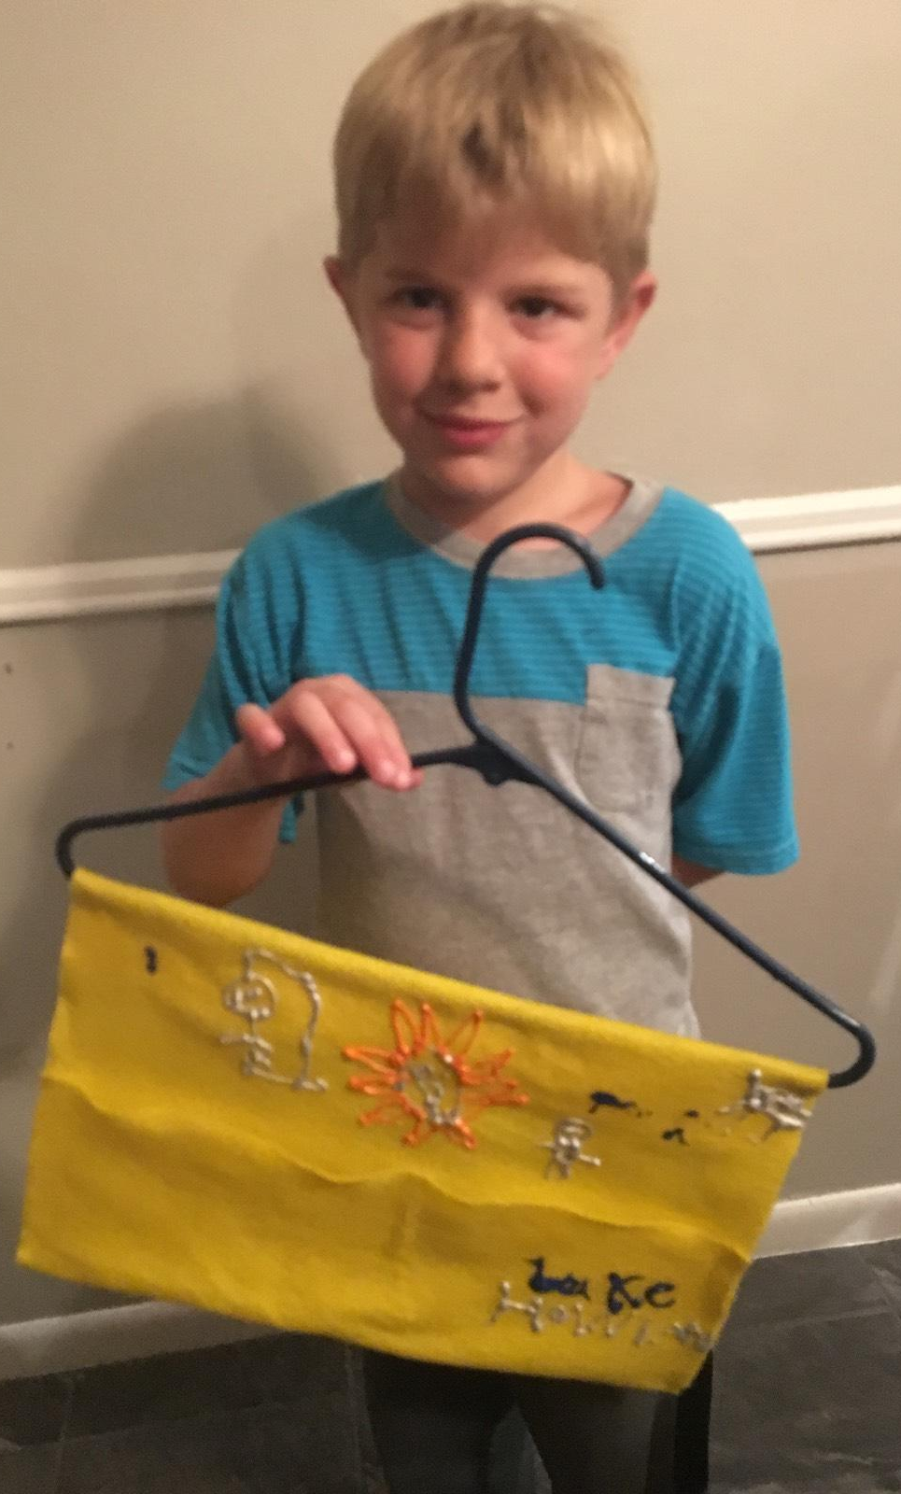

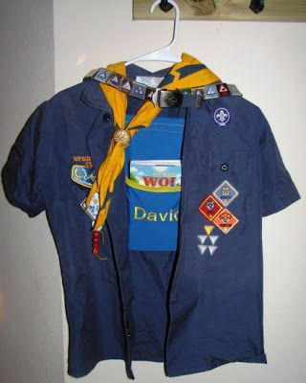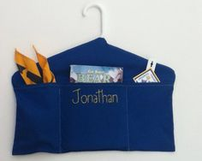

www.pinterest.com/pin/133208101451084579 https://i.pinimg.com/236x/b9/c2/7c/b9c27c456a7e34964126414b64147e59.jpg

